**Week 3 Assignment – Landing, Login, and Enrollment**

**Pages Development**

Laura Harrington

University of Arizona Global Campus

CST499: Capstone for Computer Software Technology

Instructor Rangitsch

June 3, 2024

There are many strategies and languages that can be used to create software code. Selecting a coding language is important not only to the programs functionality but for keeping the code uniform throughout the implementation process. In the student portal PHP is utilized to prepare the logistics of the code and the program is run through XAMPP as its web server. PHP is a great programming language to use because it’s a bit easier to read and is very learnable. This week a few of the main pages of the student portal were created and connected to a MySQL database. In this paper I will explain how to run a PHP file through XAMPP while demonstrating the system that has been developed so far and what coding techniques were used.

To run a file through XAMPP you must first have the XAMPP downloaded and installed onto your computer. This step is crucial because you must have XAMPP on the computer to run the file, but it also creates the subfolder in the C drive to save the files too. Once the application is launched (XAMPP Control Panel) the user will click start on Apache and for this specific project MySQL also(lo Storto, 2023). Once everything is running a browser is opened and the user will need to navigate to http://localhost if there are already PHP files saved in the htdocs folder they will appear as links on the landing page (lo Storto, 2023). However, if there is no file yet a piece of PHP code can be created saved with the name of the file and .php that part is very important because it identifies it as a PHP file, as an example the file can be called registersp.php. If you have several files, it is best practice to save them all to a folder within htdocs. For the student portal project, I called my folder Gen 499 project, and it keeps all of my different php files for this one project in one place. Then you can navigate to <http://localhost/the> name of your project folder here/. That will display only the PHP files included in that folder. Lastly you select the hyperlink of the file you want to start with. You can begin running user tests on the system and any errors will be called out. The XAMPP localhost will also give the line of code that the error occurred on.

**Figure 1  
Project folder in XAMPP subfolder - htdocs**

To complete the pieces of this week’s assignment I knew I needed a MySQL database and at least one table. This week’s focus was the main pages of the system the landing student portal page where students could register or login. I started with the table creation to ensure I had all the objects from the necessary class to include in my code for registration and login pages. When creating the table I also knew one of the requirements was to ensure all users had a unique username, so I planned on putting an error message in my code but also setting the username as the primary key in my tblstudent table. I took the class diagram created in week 2 and pulled the user registration information from it. The database as a whole will hold 2 different classes defined as tables. The first table is tblstudent which holds all required information for the student’s successful enrollment and future logins to the system. The second table which hasn’t been created yet will focus on the classes that the student can add or delete from their schedules.   
 A few of the MySQL functions I used in my code were SELECT FROM and INSERT functional statements. These were the main ones needed to get the functionality from my PHP code to the table within the database. I needed the INSERT function to pull the user information entered by the student and store it in the correct rows within the table. When logging in the code must pull information from the database to make sure the username and password match up with a student registered in the database before allowing access to their profile. The SELECT function is used in code to pull information directly from the database (*SQL SELECT statement*, n.d.)

**Figure 2 & 3  
MySQL Database and Table**

**Figure 4**

**Config source code PHP**

**Figures 5 - 7  
Student portal home page and PHP source code**

**Figure 8 – 10**

**Login screen with PHP source code**

**Figures 11 - 14  
User registration page and PHP source code**

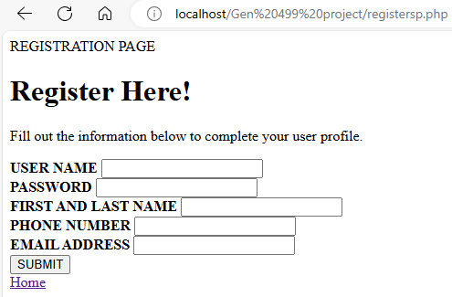

The steps taken to create the registration page was first to brainstorm all items I needed to incorporate into my code and the correct name/spelling for each one I had given it in the database. I wanted the registration page to be welcoming and give the user a sense of excitement for creating their account. So, I made the message large and bold. I created the basic rules or logic behind the code by calling the configsp.php file into the code. This links the registration page to my database as well. From there I listed out the objects needed to be entered by the user and set parameters with the use of if/else statements to make sure that the username entered was compared to existing usernames in the database and if it matches more than 0 usernames to give an error message (Connolly & Hoar, 2018). The else statement goes into action if the username is unique and creates the user by putting all information entered into the corresponding rows of the table within the database. Included at the bottom is a home button which when clicked navigates them back to the student portal so that file is also referenced within the registration PHP file.

**Figures 15 & 16**

**Student profile page and PHP source code**

**Figure 17 & 18  
Logout button with PHP source code**



**References**

Connolly, R., & Hoar, R. (2018). Fundamentals of web development (2nd ed.). Pearson.

lo Storto, A. (2023, November 15). *How To: Run PHP with XAMPP* - Alex lo Storto. Medium. https://medium.com/@lostorto.business/how-to-run-php-with-xamp-d3318f7a7735

*SQL SELECT statement*. (n.d.). W3schools.com. Retrieved June 4, 2024, from https://www.w3schools.com/sql/sql_select.asp